Activity 1

1.
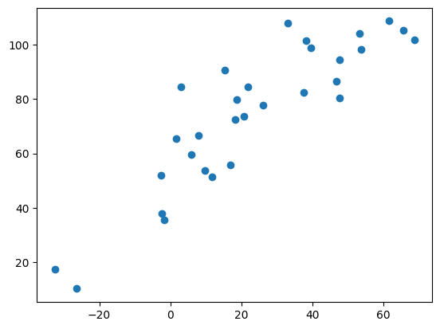
The exercise focused on analysing data using covariance and Pearson correlation to assess relationships between variables. Covariance indicated how two variables varied together, but its interpretation was limited by scale. In contrast, Pearson’s correlation provided a clearer picture with values ranging from -1 to +1, making it easier to judge the strength and direction of the relationship. Implementing these techniques in Python enabled us to interpret real-world data more effectively and understand when to use each statistical measure..
data1: mean=23.502 stdv=25.228
data2: mean=74.650 stdv=26.041
Covariance: 599.774
Pearsons correlation: 0.883

2.
During this task, various Google Colab programs were run to analyze the difficulties often encountered in unprocessed data and the techniques employed to manage them. The visual below represents the output of a linear regression model developed using Pearson’s correlation metric.
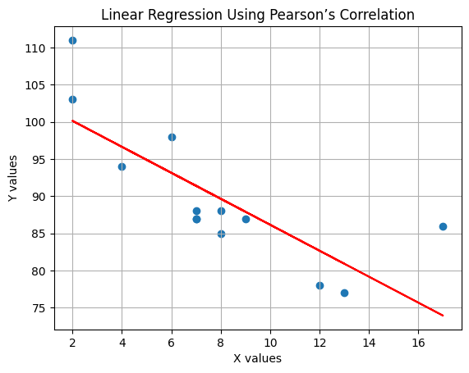
Correlation: -0.784

3.
The goal of this task was to explore polynomial regression by fitting a third-degree polynomial to a non-linear dataset. We used NumPy to calculate the best-fit curve and matplotlib to visualise the results. The plotted curve followed the shape of the data much more closely than a linear model would, highlighting how polynomial regression can handle more complex trends. This activity emphasised the importance of choosing the right model for the right data, especially when visual analysis shows clear curvature that linear regression can't capture.
